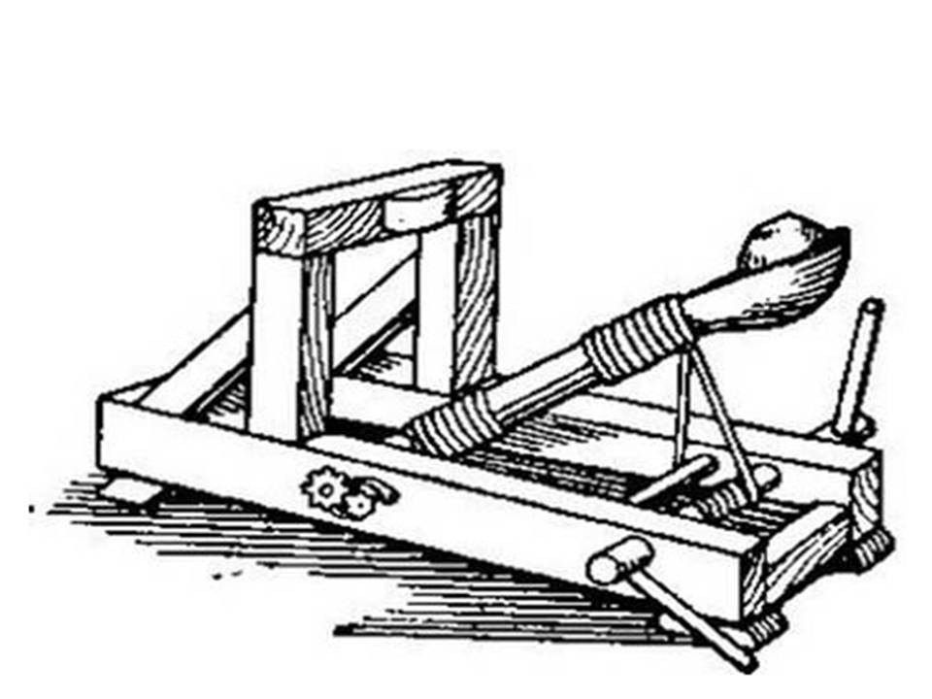
Name: ___________________________
Catapults
c
Scenario:
Our School is being attacked by zombies. We must use the supplies in the classroom to build a catapult that we can launch from the top of the school to accurately eliminate them.
Objective:
Your job as a team is to design and construct a catapult that will launch a ping pong ball the farthest distance traveling in the straightest line. In a series of trials, your team must discover the ideal relationship between the launch angle, distance, and force for your catapult.
Materials and Tools:
- 1 plastic spoon | 4. 2 straws | 7. Scissors
- 2 rubber bands | 5. 12” String | 8. Glue
- 8 craft sticks | 6. 12” masking tape | 9. 1 piece of cardboard
Limitations:
1. The launcher must be completed by the end of the class Tuesday.
2. You can only use the materials provided, but you do not have to use all of them.
3. Launcher must be portable.
4. You will not be able to touch the ball when launching. The ball may not be pushed, pulled, or thrown.
5. The launch will be judged by the distance the ball flies before hitting the ground. We will mark the first place the ball hits the ground.
6. You will get 3 trials the day of testing.
Instructions:
1. Brainstorm and Sketch a minimum of 3 ideas for your device
2. Attain your materials from table after sketches have been approved
3. Construct your device
4. Test
Testing:
Each foot traveled by the ping pong ball in a straight line will be worth 1 point. Each foot the ping pong ball lands away from the center line will be a deduction of 1 point. The team with the highest point total will WIN!
Using a pencil, Draw thumbnail sketches that communicate your ideas in the space below
Idea 1
Idea 2
Idea 3

